Master Shepherd’s Course Development

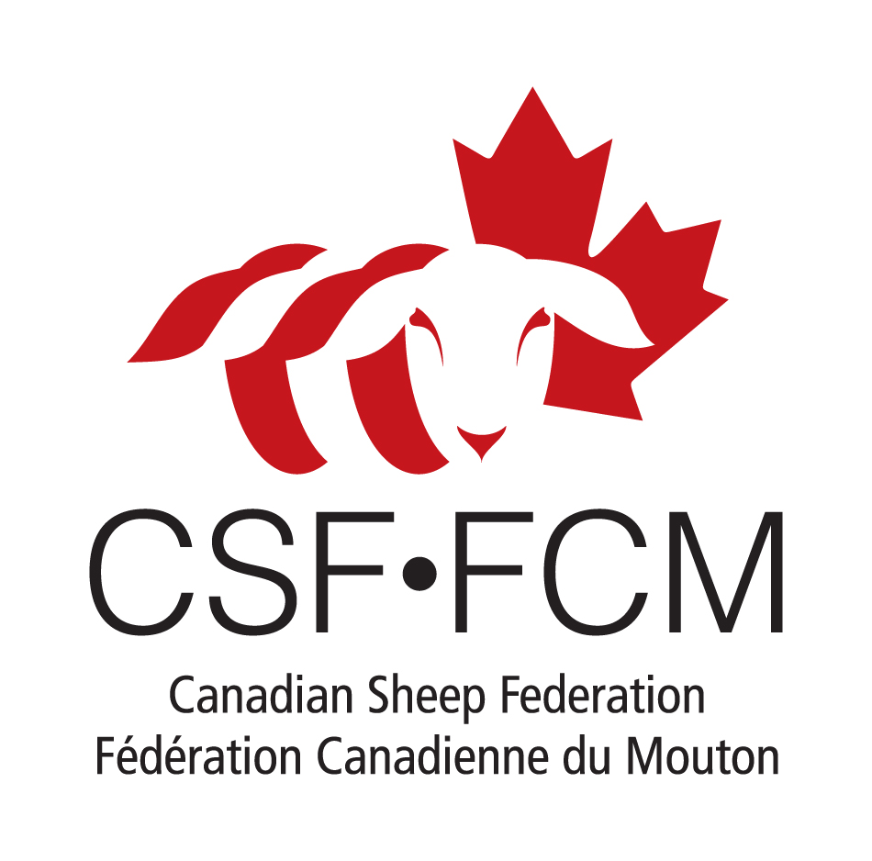

Final Report
February 28, 2012

Agriculture and Agri-Food Canada (AAFC) is pleased to participate in the production of this report. AAFC is committed to working with industry partners. Opinions expressed in this document are those of the Canadian Sheep Federation (CSF) and not necessarily those of AAFC.
About this report

The following pages include background on the Master Shepherd’s Course Development project and an update on progress made by the Canadian Sheep Federation (CSF) through engagement and consultations with producers, provincial organizations, lenders, nutritionists, geneticists and government representatives. Findings/observations are based on an analysis of survey responses and various meetings and discussions with producers and stakeholders. Recommendations for the Master Shepherd’s Course Development are based on these findings. Also included is an update of the exploration for private partnerships for the Master Shepherd’s Course.

Project background

The Canadian sheep industry needs to rebuild its critical mass in order to regain its competitiveness. To accomplish this, the industry needs to develop and implement educational and support resources for existing and future producers. The Canadian sheep industry only fills 41 per cent of the domestic demand for lamb. Over the last decade, demand for lamb has increased by 30 per cent in Canada. Given this, and a growing demand on the international market for Canadian genetics, the Canadian sheep industry is poised for sustainable growth. Without the development of education and support resources to guide producers through the process of expanding and continuing to improve their production, the industry will not be able to reach its potential.

The Master Shepherd’s Course Development project is a continuation of work that the sheep industry began in 2008 with the Industry Development Project. During the first project, the industry held two roundtable meetings that resulted in an action plan being developed to increase the production of Canadian lamb. Insufficient supply is routinely cited as the key challenge facing the sheep industry (George Morris Centre 2007; Fitzgerald and Co. 2009). At industry roundtable meetings in 2008, processors and retailers requested that the industry focus on increasing supply prior to addressing issues of quality. These meetings resulted in a list of action items that the industry believed to be necessary in order to ensure the successful increase of supply; including the development of skill-building tools to support expanding producers.

Lack of supply continues to be an issue and has been further discussed at successive Sheep Value Chain Roundtable meetings held in 2010 and 2011. Resources that could be delivered to producers as part of this project could be a turning point in addressing a long-term issue that is becoming increasingly imminent as the industry loses the critical infrastructure necessary to support current and future production.

To ensure that supply is increased in a sustainable manner, producers must have access to information and support that will facilitate success. Work done by Alberta Lamb Producers, the Ontario Sheep Marketing Agency and the Canadian Sheep Federation, have indicated that producers who are interested in joining the sheep industry, or expanding their production are in need of educational resources and tools. This work has allowed the industry to recognize what it needs to do to increase the supply of Canadian lamb. Given the general lack of emphasis on extension at a provincial level, it is increasingly falling on commodity organizations to find ways to educate producers. Recognizing this, the Canadian Sheep Federation and its provincial partners are committed to enhancing producer education.

Progress to Date

To date, CSF has conducted a needs analysis of what types of resources currently exist and what would be considered helpful to develop for those producers interested in strengthening their business and increasing production and profitability. This has been carried out in a number of ways, including telephone interviews, face-to-face discussions and online surveys. For the most part, results confirmed assumptions, but there were also a few surprises.

Interviews with General Managers/Executive Directors of Provincial Sheep Organization
Provincial sheep organizations have a significant role to play in the Master Shepherd’s Course – from the needs analysis phase through to development and delivery. It is very different from CSF’s role, which is to facilitate the process and ensure there are tools in place for provinces to support their producers’/industry’s growth and create conditions for success.

To this end, CSF coordinated telephone interviews with each of the provincial sheep organizations GMs/EDs to gather their insights on producer education. Their comments are reflected in the findings and recommendations portions of this report.

This group was also given the opportunity to review/comment on the resource list for content (Appendix C).

Producer survey
The Canadian sheep industry is as diverse as the people involved in it, and although CSF has a sense of the scope and types of issues facing producers, we reached out through a survey to determine the specifics of what producers want access to. CSF was encouraged by the number of sheep producers who took the opportunity to make their opinions known and to influence the content and format of the program.

A 21-question, online survey was drafted with two main parts – production and information need/availability. The survey was distributed via email. There were 244 respondents in total with good representation from across the country (with the exception of NL).

Number of respondents by province

BC | AB | SK | MB | ON | QC | NB | NS | PEI | NL
15 | 62 | 37 | 20 | 41 | 10 | 3 | 33 | 6 | 0
Note: these numbers do not total 244 as 17 respondents opted not to share their provincial info.

Detailed results of the survey are available in Appendix A.

In addition to the survey, CSF met with numerous producers face-to-face across the country at industry events and meetings. These discussions were in keeping with the survey findings.

Stakeholder survey
A seven-question, online survey was drafted and distributed via email to approximately 50 industry stakeholders including nutritionists, lenders, geneticists and predation specialists. The purpose was to get their input on what resources/skills they think are lacking/needed among producers.

Recipients were encouraged to forward the survey to their colleagues. Forty-seven stakeholders responded – the majority (28) service clients in Ontario; Nova Scotian respondents were a distant second with seven.

Detailed results of the survey are available in Appendix B.

Review of existing resources
CSF engaged in an audit of existing resources for sheep producers. The team of reviewers included Fred Baker (independent consultant/sheep industry veteran); Anita O’Brien (Sheep & Goat Specialist, Ontario Ministry of Agriculture, Food and Rural Affairs); Gordon Schroeder (Executive Director, Saskatchewan Sheep Development Board); and Jonathan Wort (Ruminant Specialist, AgraPoint).

The audit team reviewed more than 60 educational resources, which include training programs, factsheets, websites, manuals and books from Canada and around the world. Sources include universities, colleges, industry associations, and provincial and territorial governments.

These resources are currently being categorized and uploaded to the CSF website for nation-wide access.

Detailed results of this audit are available in Appendix C.

Findings/observations

- There is both a need and interest in education/training for top-level sheep producers on a wide range of topics
- There is not a clear trend in producer needs – this is not surprising considering the complexity of the industry and the fact that the country is so diverse (geographically and marketwise)
- Topics that producers expressed the most interest in include: flock health, business management and planning, flock genetics and breeding
- There are some differences between what topics producers indicated were important to them for information/training vs. which topics they would be willing to learn about at a cost. For instance, business management is ranked as very important, but not something they are willing to pay for.
- There is little difference when comparing responses by province, with the exception of the marketing category
- For the most part, what producers think they need to know is consistent with what
stakeholders think producers need to know. For instance, they agree on the need for added information/skills related to business management/planning and flock health, but differ on topics such as marketing (stakeholders rank it as a higher priority)
- Stakeholders believe that many small and medium-size producers are in growth/expansion mode; access to relevant information will help take them to the next level
- Producers utilize a broad range of information sources, which highlights the absence of a comprehensive resource that pulls the best of the best together
- The internet and provincial organizations are two of the most popular sources for producers to access information, which supports the use of the internet as a platform for the Master Shepherd’s Course and underscores the value of having provincial organizations play a central role in Course development and delivery

Recommendations

Offer a comprehensive continuing education program to assist lamb producers in building their farming enterprise that takes the following recommendations into account:

Utilize existing resources
- A lot of good information already exists and is being well used by producers, so there is no need to recreate the wheel (a couple of provinces have good “intro” programs and others (e.g. AB) are developing more in-depth learning modules)
- There is an opportunity for the Master Shepherd’s Course to bring everything together under one umbrella

Delivery
- As the national body representing the lamb industry, CSF is acting as a catalyst for the development of the Master Shepherd’s Course for use by each province to support their producers. Within each province, it is the provincial organization that owns the relationship with the producers. It is the intention of the CSF to help support that relationship by supporting the provincial organizations in their efforts to provide information, resources and training to producers.

Development
- The Master Shepherd’s Course will ultimately be developed by the industry, with CSF facilitating the process. It will be based on the need for a model that enables and encourages each province to tailor programs that are specific and relevant to producers in their areas.

Consistency
- CSF recognizes and appreciates the need for region-specific tailoring of producer education, both from a subject matter perspective, as well as level of detail that may be of merit in one province or region, different from another. Having said that, there is a need to have a roster of resources for producers that is consistent with best practices across the country, provides a foundation of information and resources that is relevant and useful within each province, and can be tailored to and supplemented by provincial resources as required. Some degree of consistency across the country is critical to the success and sustainability – and credibility of the industry.

Collaboration
- Here in Canada, our industry in continually challenged to raise the bar on how we perform as a viable and sustainable industry and how we are willing and able to work together to achieve that much needed collaboration across the country. Our demonstrated ability to work collaboratively on initiatives like builds credibility and proves that as an industry we are serious about ensuring our long-term sustainability and growth.

Content
- The Master Shepherd’s Course should consist of modules that cover a wide range of topics such as business planning, production benchmarking, marketing, genetics, reproductive management, lamb rearing, nutrition, animal health and disease control programs, etc. Develop content with emphasis on those expressed as priority needs by producers and stakeholders.

Format
- The Internet is a popular source for information that helps overcome geographic barriers; it was recognized in the survey as the place where many producers currently go to look for information and flagged as their preference for future material
- Ideally, the Master Shepherd’s Course would involve additional options for learning – in-person workshop sessions, on-farm visits, etc.
- Instructors would need to be identified from various fields in the industry to ensure “experts” are delivering the content
- Peer-to-peer learning is a critical component for this initiative as producers always see value in the opportunity to learn from their network; also increases sense of credibility when dealing with topics such as profitability

Fee to participate
- Producers are willing to pay a fee to participate in the Master Shepherd’s Course, but it is dependent upon the module topic
- Provincial GMs/EDs agree that there should be a fee related to participation; however, there is no consensus on whether the program needs to be an “all in” option or “a la carte”

Application process
- An application process will help ensure that the right candidates are enrolled; many provinces still have large proportion of small ‘hobby’ producers who have greater need for basic information before becoming ‘masters’
- Target candidates include:
  - successful sheep producers looking to further expand or improve profitability
  - producers moving into sheep from hog or dairy productions
  - young producers coming into agriculture who want to start out “right”
  - all share a mindset of business-focused operations that are profitable

Addressing challenges

Sustainability
- A potential challenge is the sustainability of the program. Several stakeholders suggested linking/partnering with colleges or universities or continuing education centres to make sure it has a life beyond initial funding; this will also help avoid recreating the wheel when lots of good info already exists.

Regional differences
- As mentioned previously, another challenge will be regionality of the industry; not all agree, but much of the information producers need is specific to their part of the country (e.g. marketing, feeding systems, housing, etc.) while others (e.g. health, fertility, financial management, recordkeeping) are more national in scope.

Exploration of industry funding/partnership opportunities

Without question, there is a strong need for consistency across the country of fundamental best practices. It’s critical that as an industry, we demonstrate an appetite and ability to produce and deliver Canadian Lamb in the volume and level of quality and consistency that reflects an industry serious about maintaining and growing market share.

It is very important to the success of a national program like this, that each and every province support the concept of national standards and practices, and embrace their role in the development and delivery of such training and support materials.

Support in the form of financial sponsorship has been examined in terms of the viability of engaging organizations that are seen as industry stakeholders. This list (see Appendix D) represents the range of organizations that in direct or indirect ways have an interest in the Canadian sheep industry. Some of these organizations are national in scope, while others would have more of a provincial/regional interest (e.g. Viterra).

Based on the need for provincial ‘ownership’ of a training program of this nature, it is deemed premature to approach industry stakeholders at this point – prior to the next steps of development process, deliverable details and timelines being identified.

Based on funding and other resource considerations, it may be decided moving forward, that it is most appropriate/viable for the individual provinces to take ownership of the development and delivery of training and related resources (with an ongoing focus on identifying opportunities to leverage good resources being developed at a provincial level for use in other provinces across the country). In this scenario, it would be recommended that the provincial organization, in collaboration with CSF, approach industry stakeholders within their area to become sponsors of the program. The challenge, in the provincially driven model, will be in balancing the need for nation-wide consistency in basic practices, with the need for provinces to ‘own’ the content and have material that is relevant and as specific to their needs as possible.

Therefore, the plan for identifying and engaging industry stakeholders as sponsors or partners in the program, should be more fully developed to reflect the audiences and reach of the program, once those have been finalized (e.g. a more provincially driven/focused program would appeal to different types of sponsors than a program that focuses exclusively on national organizations).
APPENDIX A – PRODUCER SURVEY & RESULTS

PART 1: Production

- Management and Business Planning

This section relates to establishing and growing your enterprise while managing it with a view to maximizing profitability. Rate the significance of each topic to you using a scale of 1 – 4 where four indicates that information & training on the topic is very important to you and 1 indicates that it is unimportant to you.

- Goal setting
- Determining your COP (cost of production)
- Formulating business plans
- Enterprise accounting
- Accessing capital
- Succession planning
- Planning and decision making
- Regulations affecting your business
- Business risk management
- Record keeping
- Identification and traceability

Results:

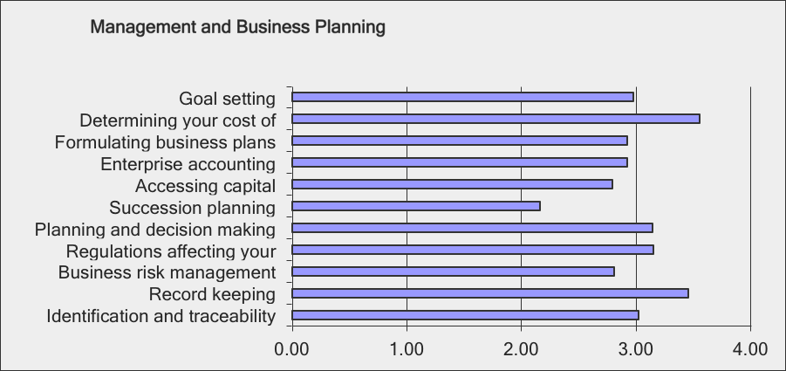

- Infrastructure

This section relates to the facilities and infrastructure required for your enterprise and using it with a view to maximizing profitability. Rate the significance of each topic to you using a scale of 1 – 4 where four indicates that information & training on the topic is very important to you and 1 indicates that it is unimportant to you.

- Building design and layouts
- Handling facilities
- Ventilation
- Manure & nutrient management
- Dead stock disposal
- Water and feed infrastructure
- Machines & equipment
- Stock densities
- Confinement systems – hybrid systems –extensive systems

Results:

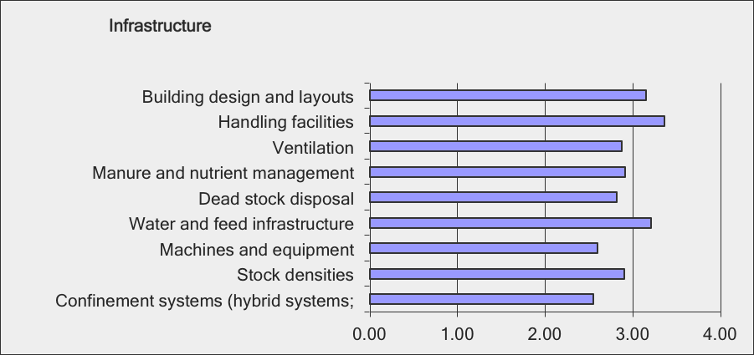
- Flock Health

This section relates to the health of your flock and the effects of flock health on profitability. Rate the significance of each topic to you using a scale of 1 – 4 where four indicates that information & training on the topic is very important to you and 1 indicates that it is unimportant to you.

- Managing profit limiting diseases and conditions
- Biosecurity
- Managing a closed flock
- Managing parasites
- Flock health programs
- Vaccinations and blood tests
- Reducing the flock turnover rate

Results:

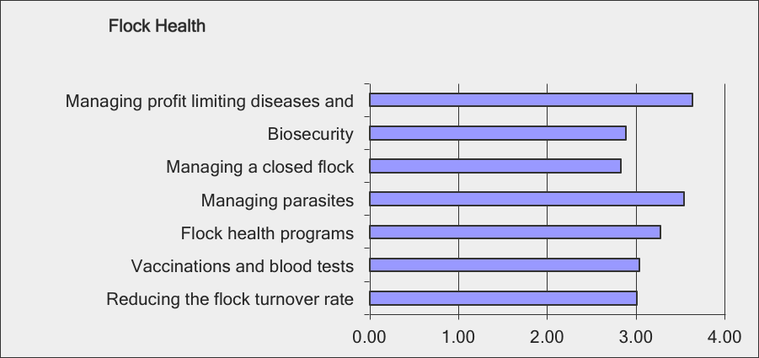

- Flock genetics

This section relates to the establishing and managing the genetic make-up of your flock and the effects on profitability. Rate the significance of each topic to you using a scale of 1 – 4 where four indicates that information & training on the topic is very important to you and 1 indicates that it is unimportant to you.

- Using terminal sires
- Interpreting ROP indicators
- Managing maternal lines
- Matching breed & environment
- Selecting breeding stock
- Selecting for pounds of lamb sold

Results:

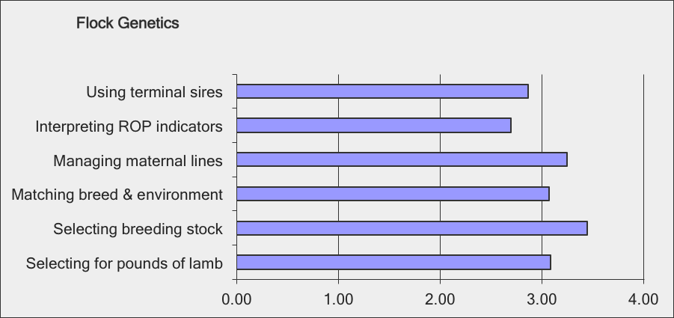

- Nutrition

This section relates to the nutritional requirements of your flock and the effects on profitability. Rate the significance of each topic to you using a scale of 1 – 4 where four indicates that information & training on the topic is very important to you and 1 indicates that it is unimportant to you.

- Balancing requirements at various stages of production cycle
- Feeding alternative feeds
- Managing forage
- Feedlot and pasture finishing

Results:

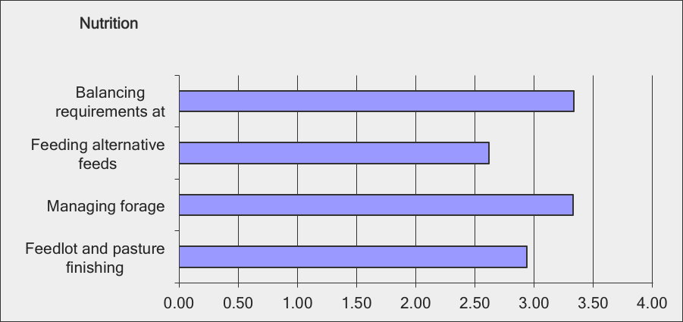

- Breeding

This section relates to issues that affect successful breeding seasons. Rate the significance of each topic to you using a scale of 1 – 4 where four indicates that information & training on the topic is very important to you and 1 indicates that it is unimportant to you.

- Managing rams
- Managing fertility
- Energy requirements pre and post introduction of rams
- Maximizing conception

Results:
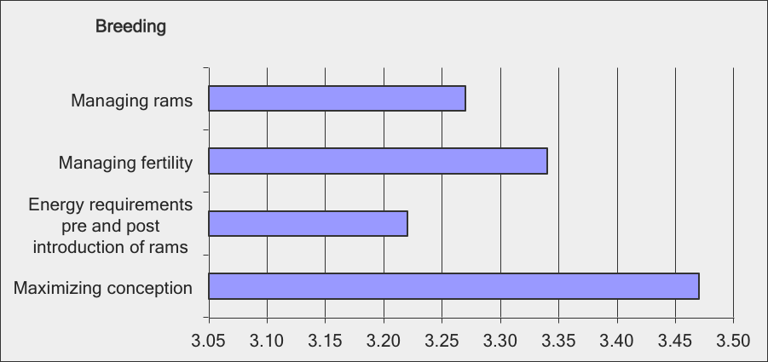

- Lambing

This section relates to issues that affect the number of lambs born live, weaned and sold. Rate the significance of each topic to you using a scale of 1 – 4 where four indicates that information & training on the topic is very important to you and 1 indicates that it is unimportant to you.

- Preparing for lambing
- Lambing facilities and set-ups
- Pasture lambing & confinement lambing systems
- Dystocia and weak lambs
- Managing mortalities (reducing mortality new born to 50 days)
- Neonatal diseases and conditions
- Illness in weaning pens, on pasture & finishing pens

Results:

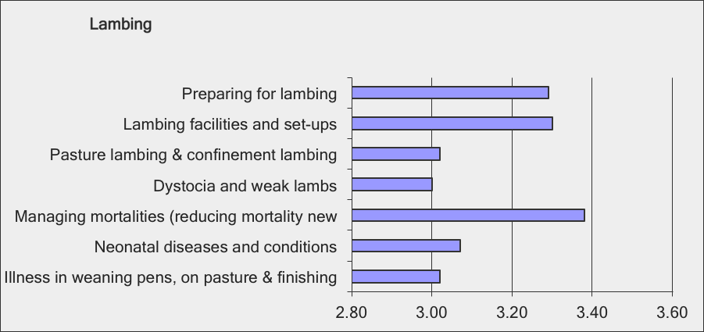

- Marketing

This section relates to decisions on selling your lamb crop. Rate the significance of each topic to you using a scale of 1 – 4 where four indicates that information & training on the topic is very important to you and 1 indicates that it is unimportant to you.

- Live trade
- Auction markets
- Cooperative marketing
- Drovers and feedlots
- Forward contracting
- Developing your own markets

Results:

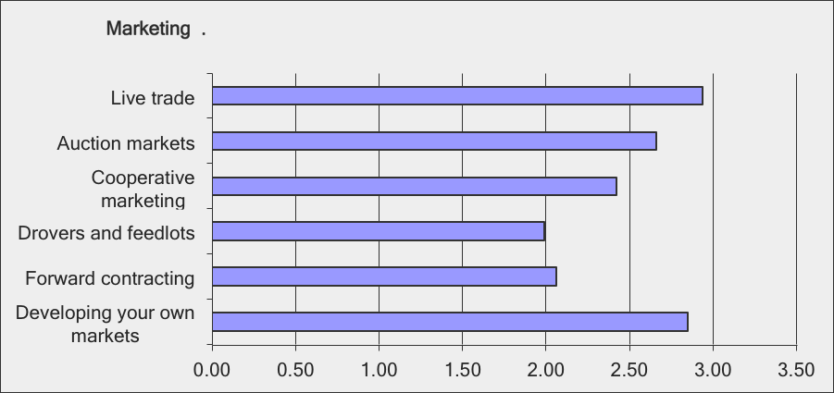

- How often would you say that you search for information about predation including prevention & solutions such as the use of guardian animals, trapping and hunting to inform yourself or to resolve predation issues caused by wild or domestic predators. If never, please explain in comments box (and survey ends)

  - Daily
  - Weekly
  - One or more times per month
  - Seasonally during production cycles
  - Seldom
  - Never

Results:

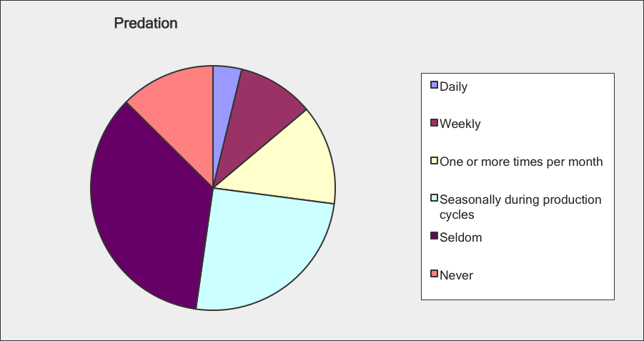

- Do you feel that information on managing predation is available to you when you need it? Tick the box which most closely represents your view.

  - Information is readily available whenever I need it
  - Information is mostly available but from different sources
  - Information is sometimes available
  - Information is difficult to find
  - I can never find what I need
  - None of the above, please explain

Results:

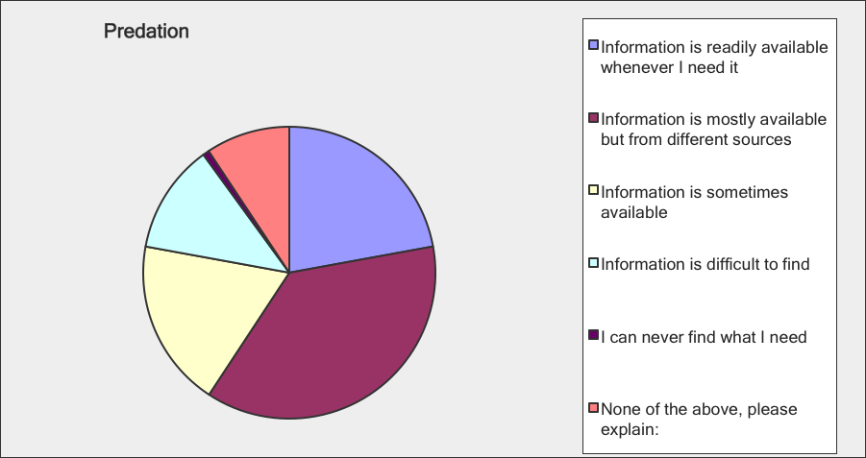

- How current and useful do you feel the information on predation is? Please tick the box which most closely represents your view.

  - Information is current and useful
  - Information is dated but is still relevant
  - Information is dated and sometimes not relevant
  - I often question the usefulness of what I find
  - None of the above, please explain

Results:

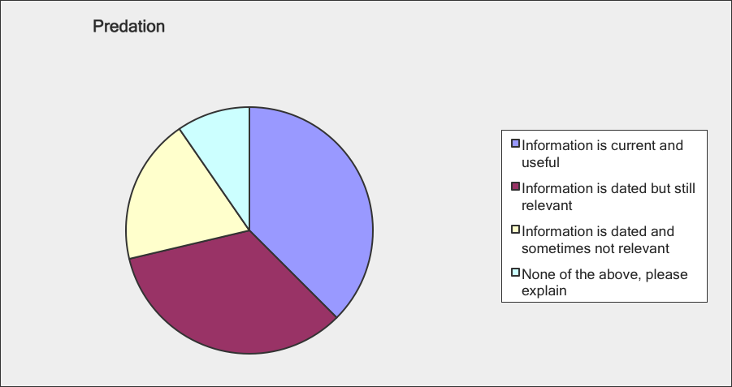

- When you need information about predation for your farming operation, where do you search? Please tick all that apply and add any additional sources in the comments box.

  - Provincial Sheep Organization & website
  - Provincial sheep organization seminars and newsletters
  - Provincial agriculture department extension office
  - Provincial agriculture department websites
  - Neighbours
  - Local hunters
  - Dog breeders
  - Municipal offices
  - Local veterinary office
  - Provincial veterinary office
  - Fact sheets
  - Personal library of books & journals
  - The farm press
  - Public library
  - Scientific journals
  - Open internet
  - Social media
  - Canadian university websites
  - Foreign university websites
  - Other: please list

Results:

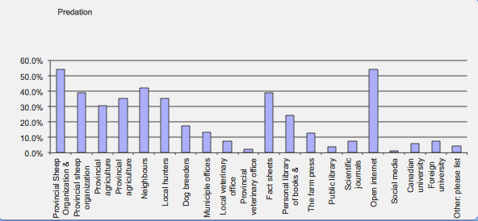
PART 2: Information need and availability

This part of the survey relates to your views on the need for, the availability and the reliability of additional information for use in operating and managing your sheep production enterprise.

- In which province is your lamb production enterprise situated?
- BC
- ALTA
- SASK
- MAN
- ON
- QUE
- NB
- NS
- PEI
- NFLD

Results:

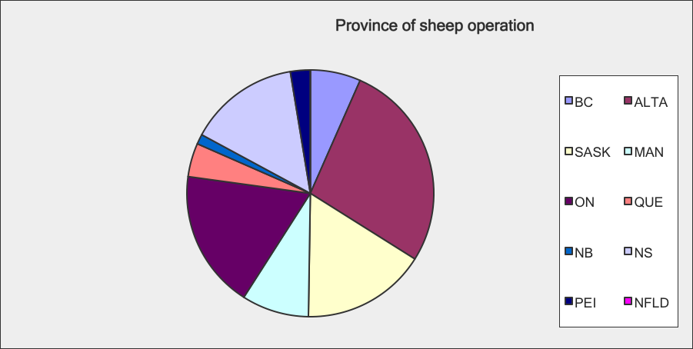

- How often would you say that you search for production and management information for your lamb production enterprise in order to learn or solve problems? If never, please explain in comments box (and survey ends)

- Daily
- Weekly
- One or more times per month
- Seasonally during production cycles
- Seldom
- Never

Results:

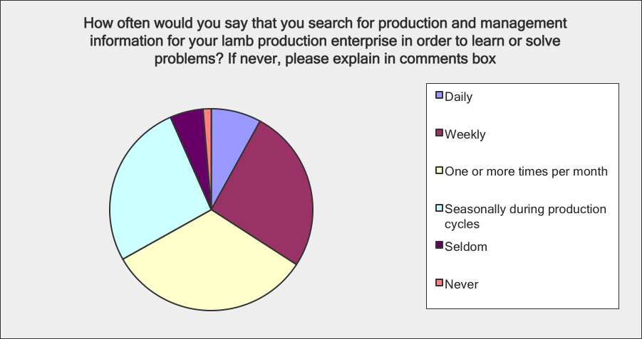

- Do you feel that appropriate sheep production and management information is available to you when you need it? Tick the box which most closely represents your view.

- Information is readily available whenever I need it
- Information is mostly available but from different sources
- Information is sometimes available
- Information is difficult to find
- I can never find what I need
- None of the above, please explain;

Results:

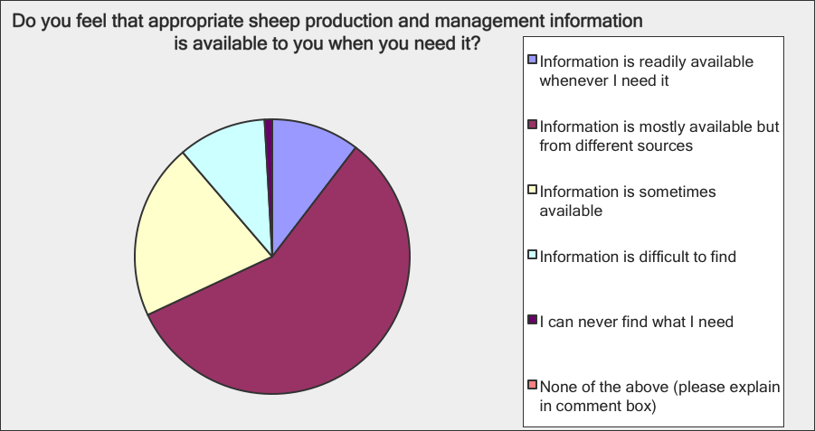

- How current and accurate do you feel the sheep production and management information you access is? Please tick the box which most closely represents your view.

- Information is current and accurate
- Information is dated but is still relevant
- Information is dated and sometimes not relevant
- I often question the usefulness of what I find
- None of the above, please explain

Results:

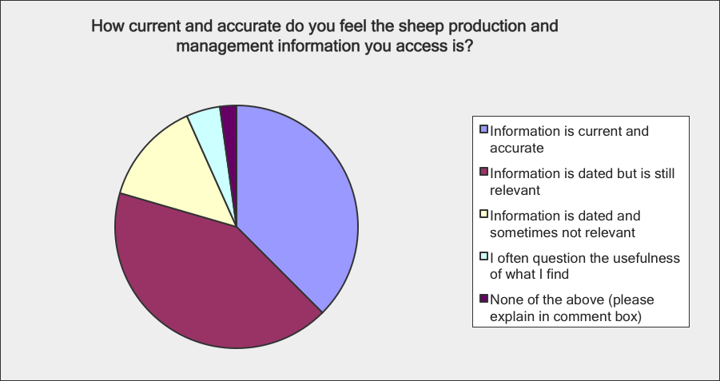

- When you need production and management information about lamb production for your farming operation, where do you search? Please tick all that apply and add any additional sources in the comments box.

- Provincial Sheep Organization & website
- Provincial sheep organization seminars and newsletters
- Provincial agriculture department extension office
- Provincial agriculture department websites
- Neighbours
- Local veterinary office
- Provincial veterinary office
- Fact sheets
- Personal library of books & journals
- The farm press
- Public library
- Scientific journals
- Open internet
- Social media
- Canadian university websites
- Foreign university websites
- Other: please list

Results:

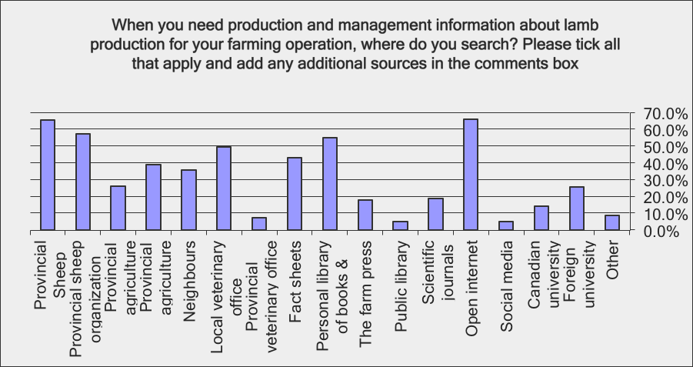

- Please rank the following sources, in the order you would use them, to find the production and management information you need. If you do not use, place an X in the box.

- Provincial Sheep Organization & website
- Provincial sheep organization seminars and newsletters
- Provincial agriculture department extension office
- Provincial agriculture department’s website
- Neighbours
- Local veterinary office
- Provincial veterinary office
- Fact sheets
- Personal library of books & journals
- The farm press
- Public library
- Scientific journals
- Open internet
- Social media
- Canadian university websites
- Foreign university websites
- Other: please list

Results:

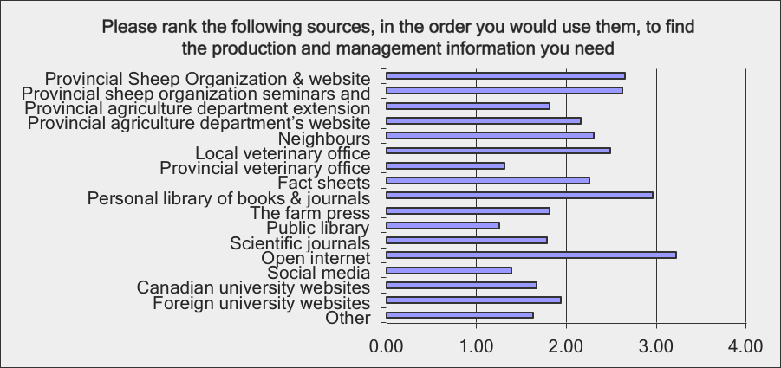

This section surveys your preferences for receiving information and training.

- Please indicate your preference for the following course and information formats

- Electronic newsletters
- A dedicated website
- Classroom seminars with practical demonstrations
- Classroom seminars
- A web based course
- Field days
- Presentations at regional and annual general meetings

Results:

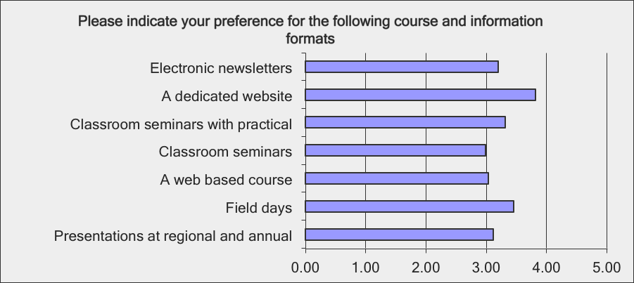

20. If resources are not available to deliver information and training during field days and/or in classrooms, what value would you be willing to pay per module for the following modules.

Choices are:
- A flat rate of $100 per module
- A flat rate of $75 per module
- A flat rate of $50 per module
- Varied depending on module
- Unwilling to pay anything

Modules:
- Management and Business Planning
- Infrastructure
- Flock Health
- Flock genetics
- Nutrition
- Breeding
- Lambing & management
- Marketing

Results:

Most respondents answered that the cost they’d be willing to pay varied depending on the module. The following ranks which modules the respondents would be most willing to pay something for. “Flock health” and “nutrition” hold the most value, followed closely by “lambing and management.”

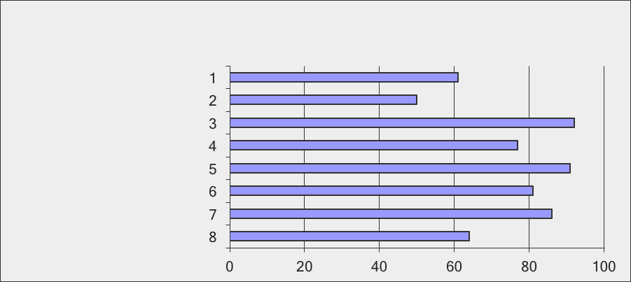
APPENDIX B – STAKEHOLDER SURVEY & RESULTS

- Do sheep farmers form part of your client base?

- Yes – continue
- No – thanks and exit

Results:

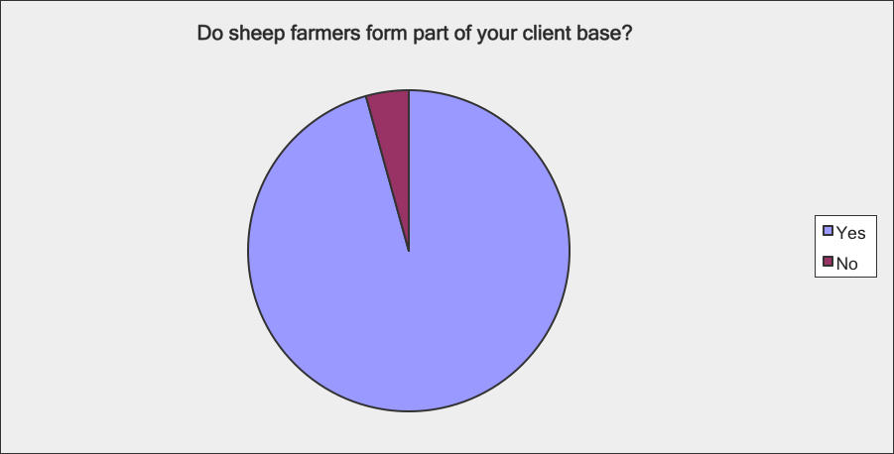

- In which province(s) do you conduct your business? (Check all that apply)

  - Nationally
  - BC
  - Alberta
  - Saskatchewan
  - Manitoba
  - Ontario
  - Quebec
  - New Brunswick
  - Nova Scotia
  - Prince Edward Island
  - Newfoundland

Results:

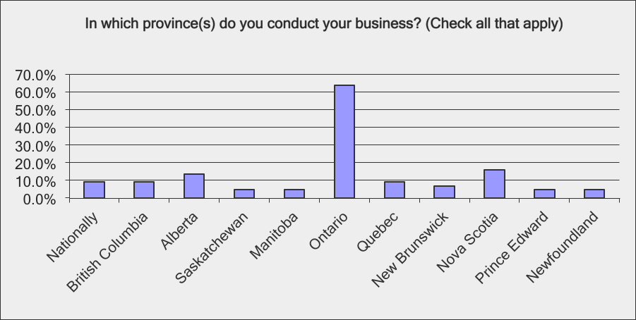

- Thinking of your sheep producing clients, in which age ranges would you estimate that they fall into? (check those that apply)

- 20 – 39
- 40 – 49
- 50 +
- Don’t know

Results:

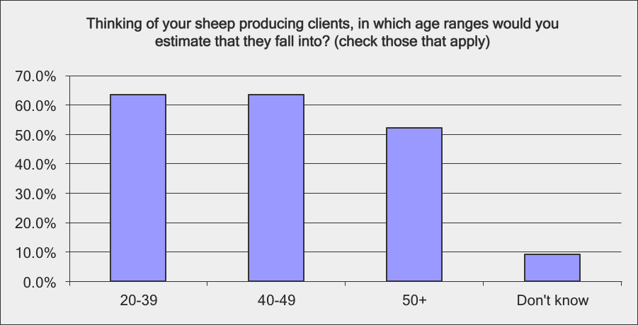

- Thinking of your sheep producing clients, how would you describe their farm business? (check those that apply)

- Small and static
- Small and expanding
- Medium and static
- Medium and expanding
- Large and static
- Large and expanding

Results:

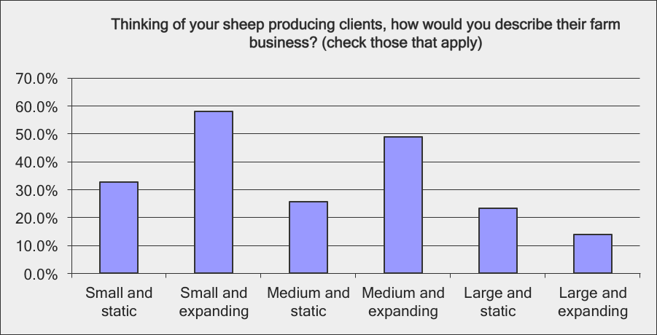

- In which of the following areas do your sheep producing clients seek your expertise? (check those that apply)

  - Finance & business planning
  - Animal nutrition and feeding
  - Flock health
  - Genetics & breeding
  - Sales & marketing
  - Predators & predation
  - Other, please list

Results:

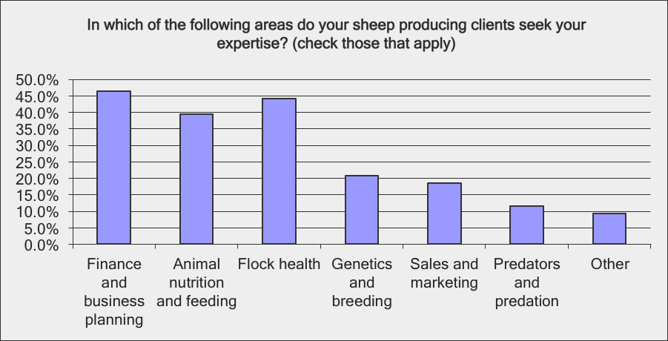

- Thinking about your sheep producing clients, how would you assess their knowledge in each of the following areas; (1=low, 2=some knowledge, 3=knowledgeable 4=can’t say)

Farm Business Management

- Goal setting
- Determining their COP (cost of production)
- Formulating business plans
- Enterprise accounting
- Accessing capital
- Succession planning
- Planning and decision making
- Regulations affecting your business
- Business risk management
- Record keeping
- Identification and traceability

Results:

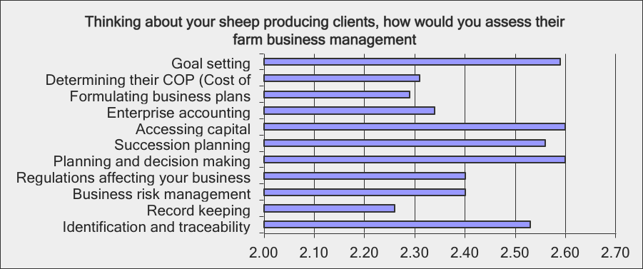

Flock Health

- Managing profit limiting diseases and conditions
- Biosecurity
- Managing a closed flock
- Managing parasites
- Flock health programs
- Vaccinations and blood tests
- Reducing the flock turnover rate

Results:

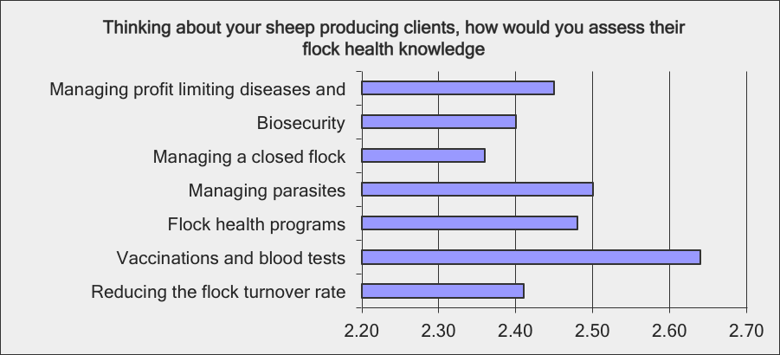

Flock Genetics & Breeding

- Using terminal sires
- Interpreting ROP indicators
- Managing maternal lines
- Matching breed & environment
- Selecting breeding stock
- Selecting for pounds of lamb sold
- Managing rams
- Managing fertility
- Energy requirements pre and post introduction of rams
- Maximizing conception

Results:

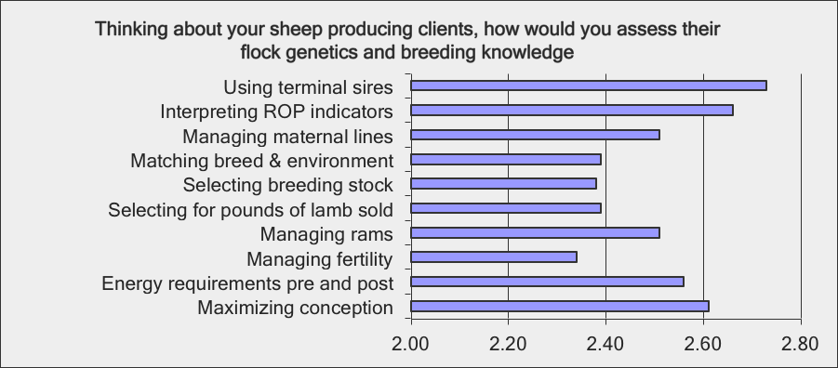

Nutrition & Feeding

- Balancing requirements at various stages of production cycle
- Feeding alternative feeds
- Managing forage
- Feedlot and pasture finishing

Results:

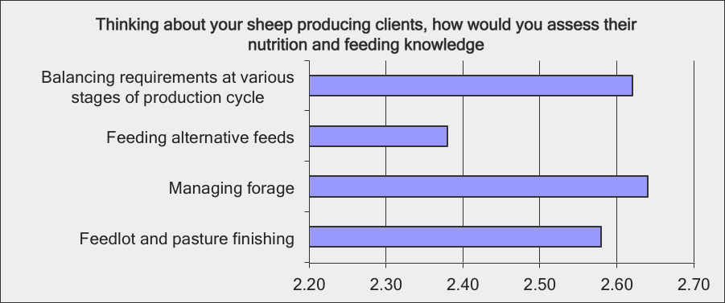

Predation

- Basic knowledge of predators
- Predation risk assessment for their farms
- Predation deterrence strategies
- Methods to deal with problem predators

Results:

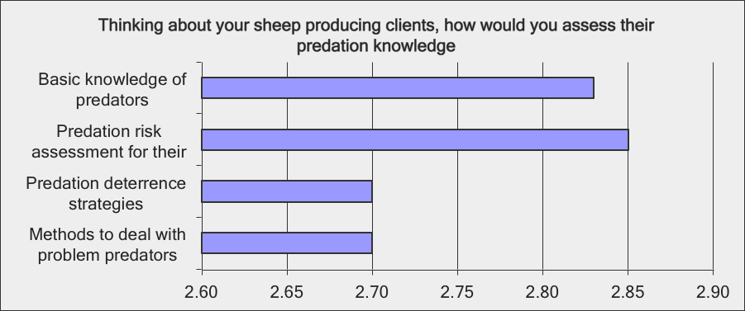

Lambing

- Preparing for lambing
- Lambing facilities and set-ups
- Pasture lambing & confinement lambing systems
- Dystocia and weak lambs
- Managing mortalities (reducing mortality new born to 50 days)
- Neonatal diseases and conditions
- Illness in weaning pens, on pasture & finishing pens

Results:

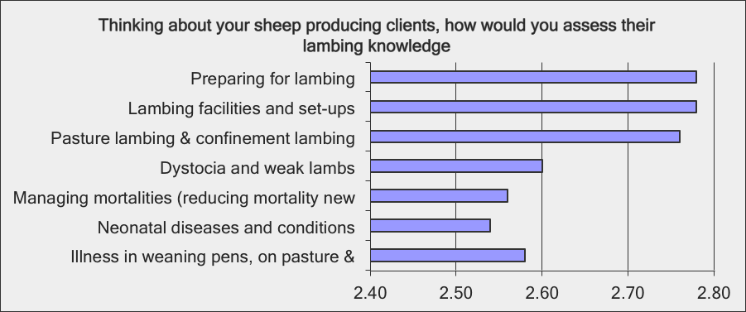

Marketing

- Live trade
- Auction markets
- Cooperative marketing
- Drovers and feedlots
- Forward contracting
- Developing your own markets

Results:

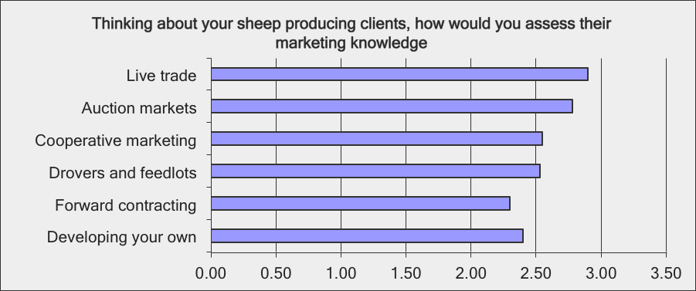

- If you were able to recommend training & additional information to your sheep producing clients, which of the following areas would you prioritize; (1=not needed, 2= low priority, 3=medium priority, 4=high priority)

- Management and Business Planning
- Infrastructure and infrastructure development
- Flock Health
- Flock genetics
- Nutrition
- Breeding
- Lambing & lamb management
- Marketing

Results:

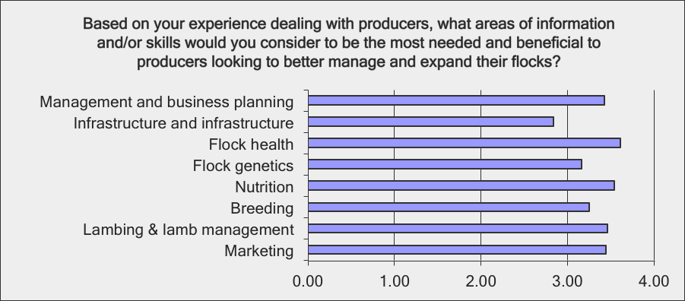

APPENDIX C – REVIEW OF EXISTING RESOURCES

Online Resources

VIRTUAL TOOL BOX

DESCRIPTION: A virtually based ‘tool box’ to assist new entrants to the Canadian sheep industry. It’s full of information producers need to know in relation to running a business and managing production. Existing producers may also find it a helpful resource as they evolve and expand their operations.

Audience: Novice
Format: HTML and PDF
Direct Link: http://cansheep.ca/cms/en/Resources/VTBox/VTBox.aspx
Date: 2011
SOURCE: Canadian Sheep Federation

CODE OF PRACTICE FOR THE CARE AND HANDLING OF SHEEP

DESCRIPTION: The Codes of Practice are nationally developed guidelines for the care and handling of sheep. They contain recommended housing, management, transportation and other animal husbandry practices.

Audience: Novice to Advanced
Format: PDF
Direct Link: http://www.nfacc.ca/pdfs/codes/Sheep%20Code%20of%20Practice.pdf
Date: 1995 (update available 2013)
SOURCE: National Farm Animal Care Council

OMAFRA SHEEP FACTSHEETS

DESCRIPTION: Series of electronic factsheets. Content sometimes difficult to find on the site. Topics are pretty complete, but sometimes provincially specific. General information without detail.

Audience: Novice to Expert
Format: HTML and PDF
Direct Link: www.omafra.gov.on.ca/english/livestock/index.html
Date: Ongoing
SOURCE: OMAFRA

SSBD SHEEP FACTSHEETS

DESCRIPTION: Series of electronic factsheets. Solid information designed for novice producers looking for basic information to get them through their first production cycles.

Audience: Novice+
Format:
Direct Link: http://www.sksheep.com/services_extension_services.htm
Date: Ongoing
SOURCE: Saskatchewan Sheep Development Board (SSBD), Saskatchewan, Canada

SHEEP PRODUCTION GUIDE

DESCRIPTION: A good general production manual. Some slight regional specifics due to genetics used in that region (eg. Strive for a lambing rate of 150%). Doesn't include anything about finishing or marketing finished lambs.

Audience: Up to Expert
Format: Online PDF
Direct Link: http://extension.oregonstate.edu/catalog/pdf/em/em8916-e.pdf
Date: 2006
SOURCE: Oregon State University Extension Service, US

INTRODUCTION TO SHEEP PRODUCTION IN ONTARIO

DESCRIPTION: Individual chapters vary in length from 10 to 60 pages. A total of 13 chapters including virtually all the topics from the MSC survey. Gleaned from other provinces and sources including factsheets. A criticism is that the content seems to change - one chapter on Business programs and funding dropped and replaced with a ewe/lamb timeline over the past two weeks. Very useful for general learning but some limitations as an everyday tool or a resource for specific problems.

Audience: Up to Expert
Format: Online
Direct Link: http://www.ontariosheep.org/SHEEPPRODUCTIONINFO/Manuals.aspx
Date: Ongoing updates since 2000
SOURCE: Ontario Sheep Marketing Agency (OSMA), Ontario

CORNELL SHEEP PROGRAM

DESCRIPTION: A good resource that includes scientific papers, research reports, fact sheets, references to other sources. It does take some searching and skill to navigate around through the layers to discover content and it would be frustrating to use to search for information to resolve specific issues. Useful as a site to surf and learn from.

Audience: Up to Expert
Format: Website
Direct Link: http://www.sheep.cornell.edu/
Date: Ongoing
SOURCE: Cornell University Animal Science Dept. Sheep Program, United States

SHEEP POCKET GUIDE
DESCRIPTION: Very general in nature. Total of five pages. Repeats a lot of the recommended practices from other jurisdictions. Not a lot of use to individuals with specific needs or who are looking for specific info with which to expand.

Audience: Novice to Intermediate
Format: Online PDF
Direct Link: www.ag.ndsu.edu/pubs/ansci/sheep/as989-1.htm
Date: 1996
SOURCE: North Dakota State University, US

GETTING STARTED IN SHEEP

DESCRIPTION: Very general information, some of which conflicts with other sources. Total of four pages. Written in easily-understood language. Page four lists a number of books and guides for beginning shepherds made available through the Sheep Development Board.

Audience: Novice
Format: HTML
Direct Link: www.agriculture.gov.sk.ca/Default.aspx?DN=58e20693-f5cb-4e92-8853-23d21a5d067b
Date: Updated in 2008
SOURCE: Government of Saskatchewan Agriculture, Saskatchewan, Canada

HANDBOOK FOR THE CONTROL OF INTERNAL PARASITES OF SHEEP

DESCRIPTION: No Canadian sheep farm should be without it. Enough said.

Audience: Novice to Experienced
Format: PDF
Direct Link: http://www.uoguelph.ca/~pmenzies/PDF/Handbook_Control_Internal_Parasites_Sheep_PMenzies.pdf
Date: 2010
SOURCE: University of Guelph, Ontario, Canada

SHEEP RESOURCES

DESCRIPTION: An eclectic mix of links to sheep-related resources including the old Canada Plan Service. Some useful stuff if just surfing the web learning about sheep and related organizations.

Audience: Anyone
Format: PDF
Direct Link: http://www.livestocktrail.illinois.edu/sheepnet/resources.cfm
Date: Ongoing
SOURCE: University of Illinois Extension, US

IOWA STATE UNIVERSITY SHEEP RESOURCES

DESCRIPTION: Factsheets are more useful than the PowerPoint presentations and slide shots. Some eg."Using co-products from corn milling industry in sheep rations" are more useful than others. The site would not be a first choice to search for solutions to Canadian sheep production conundrums.

Audience: Novice to Advanced
Format: PDF
Direct Link: https://store.extension.iastate.edu/ProductList.aspx?CategoryID=69
Date: Ongoing
SOURCE: Iowa State University, Extension and Outreach, US

MONTANA STATE UNIVERSITY SHEEP FACTSHEETS

DESCRIPTION: A series of six factsheets dealing with basic sheep production issues such as buying rams, managing during lambing season, sheep diseases body condition scoring and marketing lambs. Good basic information that is available from many sources.

Audience: Basic
Format: HTML
Direct Link: http://animalrangeextension.montana.edu/articles/Sheep/main-fact.htm
Date: Ongoing
SOURCE: Montana State University, Sheep Extension Program, US

UNIVERSITY OF WISCONSIN SHEEP FACTSHEETS

DESCRIPTION: The site provides access to Dr. David Thomas, a recognized sheep expert and also to a series of basic factsheets for both the small farm and what is referred to as commercial (larger scale) sheep operations. The site also advertises the field days sponsored by the extension program such as Techniques for out-of-season breeding" and "Selection of legumes and grass varieties for productive sheep pastures."

Audience: Basic
Format: HTML
Direct Link: http://fyi.uwex.edu/wisheepandgoat/
Date: Ongoing
SOURCE: University of Wisconsin, Sheep and Goat Extension Program, US

SPRING LAMB PRODUCTION

DESCRIPTION: A short guide to prepare a farmer entering the business with basic information including a budgeting exercise, nutrition, health issues, basic housing and labour requirements. Very useful for anyone thinking or planning to acquire a beginning flock.

Audience: Basic
Format: PDF
Direct Link: http://agalternatives.aers.psu.edu/Publications/spring_lamb.pdf
Date: 2006
SOURCE: College of Agricultural Sciences, Agricultural Research and Cooperative Extension, Penn State, US

VIRTUAL LIVESTOCK LIBRARY – SHEEP RESOURCES

DESCRIPTION: Very similar to the CSF’S Virtual Tool Box, the virtual library provides links to a broad range of resources and publications. Some are PDF, and others are html. The concept is excellent; the problem is the majority of links are broken – especially in the more important nutrition and feeding and husbandry sections, making it almost useless.

Audience: Basic to Advanced
Format: PDF and HTML
Direct Link: http://westnilevirus.okstate.edu/library/sheep.html
Date: Various dates
SOURCE: Oklahoma State University, US

SHEEP AND GOAT MANAGEMENT IN ALBERTA

DESCRIPTION: Three extensively produced manuals covering reproduction, health and nutrition available via html as a whole printable document or in chapters or for use online. The health management manual for example contains 23 chapters filling 2.9MB of information. Information is clearly written and well presented. Every Canadian sheep producer should have these manuals bookmarked.

Audience: Basic to Advanced
Format: HTML
Direct Link: http://ablamb.ca/producer_mgmt/sheep_goat_mgmt.html
Date: 2009
SOURCE: Alberta Lamb Producers, Alberta, Canada

ALBERTA LAMB FACTSHEETS

DESCRIPTION: A few of the factsheets are fairly specific to situations in Alberta, but many others would provide valuable information for all Canadian producers.

Audience: Novice to Advanced
Format: PDF and HTML
Direct Link: http://ablamb.ca/producer_mgmt/factsheets.html
Date: Various dates
SOURCE: Alberta Lamb Producers, Alberta, Canada

MAKING MORE FROM SHEEP

DESCRIPTION: The 11-module information package captures the experiences of 250 sheep producers and technical specialists and identifies major principles and procedures that optimize various areas of sheep production. Each of the modules can be read online or the manual can be purchased for $100au. The modules are comprehensive; Planning for Success, Market Focused Wool Production, Market Focused Lamb and Sheep Production, Capable and Confident Producers, Protect Your Farm’s Natural Assets, Healthy Soils, Growing More Pasture, Turn Pasture to Profit, Gain from Genetics, Wean More Lambs, Healthy and Contented Sheep. There are a series of measurement tools that can be viewed online. Although some of the content is specific to Australia, this is a useful resource for Canadian producers and could be a model for the information collected in some of the benchmark studies conducted here.

Audience: Advanced
Format: PDF and HTML
Direct Link: http://www.makingmorefromsheep.com.au
Date: 2008 plus updates
SOURCE: Meat and Livestock Australia & Australian Wool Innovation, Australia

AGRAPOINT SHEEP FACTSHEETS

DESCRIPTION: Agrapoint offers extension services to producers in Nova Scotia, PEI, NB, and occasionally Quebec and Ontario. The four current fact sheets and the three in development are available electronically. Agrapoint works as an integrated team to resolve on farm problems and provide training. Agrapoint is connected to the Nova Scotia Agricultural College.

Audience: Novice to Advanced
Format: PDF and HTML
Direct Link: http://www.agrapoint.ca/livestock.php
Date: Various dates
SOURCE: Agrapoint, Nova Scotia, Canada

SOUTH DAKOTA STATE UNIVERSITY SHEEP EXTENSION RESOURCES

DESCRIPTION: A variety of sheep-related factsheets and publications.

Audience: Novice to Advanced
Format: PDF
Direct Link: http://www.sdstate.edu/sdces/store/index.cfm#taxonomy=&keywords=SHEEP&typeVal=63&typeOfPubValue=31&index=-1&total=-1
Date: Various dates
SOURCE: South Dakota State University Agriculture Department, Sheep Extension Resources, US

Books and Manuals

SHEEP PRODUCTION HANDBOOK

DESCRIPTION: A general handbook covering sheep basics including breeding, forages, handling, health, nutrition, predator control, wool and lists of State Extension Personnel. In paper form, sections become dated while basics will remain current. It is American centric with different requirements for climate, feed sources, cougars (US) versus coyotes (Canada). A good basic information tool among others for beginning producers – intermediate managers looking to expand and to become better managers would not be adequately served.

Audience: Novice to Experienced
Format: Handbook and CD
Direct Link: http://www.sheepusa.org/Order_Materials
Date: 2000
SOURCE: American Sheep Industry Association, 9785 Maroon Circle, Suite 360, Englewood, CO, US

SUSTAINABLE WORM CONTROL STRATEGIES FOR SHEEP

DESCRIPTION: An excellent resource for managing internal parasites and dealing with increasing levels of resistance. Excellent bibliography. Some recommended products are not registered for use in Canada. A "should have".

Audience: Novice to Experienced
Format: PDF
Direct Link: www.nationalsheep.org.uk
Date: 2010
SOURCE: ISBN:09547447-3-X, Context Publications, UK

SHEEP PRODUCTION GUIDE

DESCRIPTION: A good 34-page guide with useful information as a general guide to plan an enterprise with. It draws heavily from other manuals such as the Handbook from the American Sheep Institute.

Audience: Novice+
Format: PDF
Direct Link: n/a
Date: n/a
SOURCE: ADM Alliance Nutrition Quincy, Illinois, US (www.admani.com)

THE GOOD FOOD GUIDE FOR SHEEP

DESCRIPTION: Of general interest to Canadian producers but of limited use given differences in climates, approved seeds and production products. Already becoming dated.

Audience: Advanced
Format: PDF
Direct Link: http://www.agric.wa.gov.au/objtwr/imported_assets/content/aap/sl/nut/bulletin4473.pdf
Date: 2001
SOURCE: Bulletin 4473, ISSN 1326-415X, Department of Agriculture, Meat and Dairy, Australia

SHEEP: SUSTAINABLE AND ORGANIC PRODUCTION

DESCRIPTION: A 24-page, general booklet for organic sheep production. Although it includes topics such as alternative health management, the booklet is too abbreviated in length and content to be of much use other than as an overview of the principles for organic production.

Audience: n/a
Format: Print and PDF
Direct Link: https://attra.ncat.org/attra-pub/summaries/summary.php?pub=209
Date: 2010
SOURCE: National Sustainable Agriculture Information Service, National Center for Appropriate Technology (NCAT), US

THE VETERINARY BOOK FOR SHEEP FARMERS

DESCRIPTION: This book though dated remains a key information resource for sheep farmers at all levels. Some of the more recent advances in sheep genomics are missing but there are few if any resources with pictures and descriptions that can match this volume as an aid in diagnosing and solving everyday and complicated on-farm problems.

Audience: Novice to Advanced
Format: Book
Direct Link: n/a
Date: 1990
SOURCE: ISBN 0-85236-189-0, Henderson, David C, The Farm Press, Ipswich, UK

MANAGING YOUR EWE

DESCRIPTION: 382-pages of advice for the novice and intermediate sheep producer. Topics include nutrition, housing, and equipment. It takes the producer through a number of aspects for managing breeding, lambing through weaning. Some of it is getting dated now.

Audience: Novice to Intermediate
Format: Book
Direct Link: http://www.sheepbooks.com/MYE.html
Date: 1997
SOURCE: Lawson, Laura, LDF Publications, VA, US

AN INTRODUCTION TO KEEPING SHEEP

DESCRIPTION: Much acclaimed by those who are learning to manage their newly acquired flock by working with them as they go. A little UK centric in terms of feed requirements and UK regulations.

Audience: Novice
Format: Book
Direct Link: n/a
Date: 2002
SOURCE: ISBN-10: 0954255526, Upton, Jane & Soden, Dennis, Goodlife Press, UK

LAMB PROBLEMS

DESCRIPTION: Much acclaimed by those who are learning to manage their newly acquired flock by working with them as they go.

Audience: Novice
Format: Book
Direct Link: n/a
Date: 2003
SOURCE: ISBN-10: 0963392301, Lawson, Laura, LDF Publications, VA, US

CHILLED AND WEAK LAMBS

DESCRIPTION: Much acclaimed by novice producers learning their craft by working with their flock.

Audience: Novice
Format: Book
Direct Link: http://www.sheepbooks.com/Lawson-Booklets.html
Date: 2005
SOURCE: Lawson, Laura, LDF Publications, VA, US

A MANUAL OF LAMBING TECHNIQUES

DESCRIPTION: Agnes Winter is an internationally renowned sheep veterinarian known for her ability to communicate directly with farmers. This is a well-regarded basic manual and guide for understanding the birthing process and solutions to potential and emergency situations.

Audience: Novice
Format: Book
Direct Link: n/a
Date: 2001
SOURCE: ISBN-10: 1861265743, Agnes Winter, Cicely Hill, UK

STOREY'S GUIDE TO RAISING SHEEP

DESCRIPTION: 400 pages of sound information. The information tends to be directed to small and medium-sized flocks and moderately hybridized systems but contains sound information for all.

Audience: Novice+
Format: Book
Direct Link: n/a
Date: 2001
SOURCE: ISBN: 1580172628, Paula Simmons, Story Publications Ltd., UK

RAISING SHEEP THE MODERN WAY – UPDATED

DESCRIPTION: This is the updated and revised version of the same title that was used as the bible for the back to the land movement and the resurgence of the sheep industry in the 1970s. It generally lacks information for the large flock manager and the more experience producer, but it remains a sound guide for novice and journeyman lamb producers.

Audience: Novice+
Format: Book
Direct Link: n/a
Date: 2002
SOURCE: ISBN: 0 88266 093 4, Paula Simmons, Workman Publications Co., US

A PRACTICAL GUIDE TO PROFITABLE SHEEP PRODUCTION

DESCRIPTION: Similar in content and style to the other "practical guides" on the subject. At 121 pages, it is less of an authoritative and useful resource.

Audience: Novice+
Format: Book
Direct Link: n/a
Date: 1997
SOURCE: ISBN: 0 96813 640 0, Marion Smart, Meg Smart, Aspen Hills Enterprise, UK

SHEEP AND GOAT MEDICINE

DESCRIPTION: Designed and written for veterinarians, this book is not as useful to farmers as is Henderson's Vet Guide for sheep farmers. It is 468 pages, but sometimes treats small ruminants as one species.

Audience: Practicing vets
Format: Book
Direct Link: n/a
Date: 2002
SOURCE: David Pugh, Elsevier Health Sciences, UK

MANUAL OF SHEEP DISEASES, 2ND EDITION

DESCRIPTION: This book is revised and updated from a volume specifically written for veterinarians and published at least a decade before. While more accessible to farmers now, it is perhaps now less useful for both of its intended audiences.

Audience: Vets and farmers
Format: Book
Direct Link: n/a
Date: 2002
SOURCE: ISBN: 978-0-682-05999-7, J Hindson, Agnes Winter, Wiley-Blackwell, UK

LAMENESS IN SHEEP

DESCRIPTION: This is a valuable resource for all sheep producers to understand, prevent and treat lameness in sheep caused by injury, hoof growth and disease.

Audience: Novice to Advanced
Format: Book
Direct Link: n/a
Date: 2002
SOURCE: Agnes Winter, Crowood Press, Wiltshire, UK

SHEEP AILMENTS; RECOGNITION & TREATMENT

DESCRIPTION: Recognizing whether a sheep is ill or not and if it is not well, if veterinary treatment is necessary is a challenge for new producers. This volume will help the new producer with both situations.

Audience: Novice to Advanced
Format: Book
Direct Link: n/a
Date: 2001
SOURCE: ISBN:186126397X, Straiton, Edward, Crowood Press, UK

SHEEP FLOCK HEALTH; A PLANNED APPROACH

DESCRIPTION: Neil Sargison is a sought out speaker and presenter on all facets of sheep production. His views presented in this volume present a very practical on farm approach to managing the health of the whole flock and preventing individual diseases.

Audience: Novice to Advanced
Format: Book
Direct Link: n/a
Date: 2008
SOURCE: Sargison, Neil, Blackwell Publishing

THE SHEEP RAISERS MANUAL

DESCRIPTION: This book by William Kruesi is credited with contributing to the rapid expansion of the North American sheep flock in the 1980s. It presents production processes and tips in easily understood language. Although some of the content may be a little dated in 2012, it is still a useful volume for novice producers although it is becoming increasing difficult to locate.

Audience: Novice to Intermediate
Format: Book
Direct Link: n/a
Date: 1985
SOURCE: Kruesi, William, Williamson Publications, Charlotte, VT

DAIRY SHEEP NUTRITION

DESCRIPTION: Sheep dairying is a relatively new agricultural pursuit in North America. Feeding the ewe to maximize milk production during a lactation period requires a change in mindset for the sheep producer. This volume outlines the nutritional requirements of the ewe throughout her annual cycle.

Audience: Advanced
Format: Book
Direct Link: n/a
Date: 2004
SOURCE: Pulian, G, Cannas, A, Wallington Press, Cambridge, MA; also available as an E-Book through Commonwealth Agriculture Bureau Abstracts Database (www.cabi.org)

SHEEP NUTRITION

DESCRIPTION: Understanding what is happening in the rumens of sheep is a key to increasing their performance. This book moves beyond feeding grass, hay and a pound of grain in providing the sheep producer with understandable information that intermediate and advanced producers need to maximize the performance of their flocks.

Audience: Intermediate and Advanced
Format: Book
Direct Link: n/a
Date: 2002
SOURCE: Freer, M., Dove, H., Wallington Press, Cambridge, MA; also available as an E-Book through Commonwealth Agriculture Bureau Abstracts Database (www.cabi.org)

VETERINARY PARISITOLOGY REFERENCE MANUAL

DESCRIPTION: An excellent manual to identify life cycles of parasites and assist in identifying infection rates while doing own fecals.

Audience: Experienced
Format: Book
Direct Link: http://ca.wiley.com/WileyCDA/WileyTitle/productCd-0813824192.html
Date: 2002
SOURCE: ISBN: 978-0-8138-2419-2, William J. Foreyt, John Wiley & Sons

L'ÉLEVAGE DU MOUTON

DESCRIPTION: This French manual deals with all aspects of sheep production and helps the producer master the various production practices, namely knowing about breeds, selecting sheep, optimizing reproduction, feeding sheep appropriately depending on their needs, managing buildings and many other topics. The guide gives producers a better understanding about starting up a sheep farm, marketing sheep products, the available resources in the sector and production productivity.

Audience: Novice to Experienced
Format: Binder-Guide
To order: http://www.craaq.qc.ca/Publications-du-CRAAQ/l_elevage-du-mouton/p/POVI0022
Date: 2010
SOURCE: Centre de référence en agriculture et agroalimentaire du Québec (CRAAQ)

Training

SHEEP BAG 210

DESCRIPTION: The outline of this online course is very similar to the classroom courses delivered during the OLIBS program in Ontario. This model allows producers to learn and then apply their acquired knowledge on a modular basis extended over a complete production cycle. Currently, the majority of the larger producers in Ontario are graduates of the OLIBS model – proof that the concept is effective. The content of this online program is complete but dependent on the people chosen to deliver it. The detail is scalable to Canadian conditions.

Audience: Novice to Intermediate
Format: Online and Continuing Education
Direct Link: http://acsedu.co.uk/Courses/Agriculture/SHEEPBAG@!)-233.aspx
Date: Ongoing
SOURCE: ACS Distance Education Limited UK Company No. 4624913 PO Box 4171, Stourbridge, DY82WZ, UK

THE MODERN SHEPHERD: ADVANCING SKILLS FOR ATLANTIC CANADIAN SHEEP PRODUCERS

DESCRIPTION: Course is modular and builds progressively from earlier modules. Each is delivered over weekends spaced seasonally over the year. Registration and tuition required for each module or as a package. A certificate issued on completion of all modules

Audience: Novice
Format: Distance and Continuing Education
Direct Link: http://nsac.ca/cde/courses/Contract/modernshepherd.asp
Date: Ongoing
SOURCE: Nova Scotia Agricultural College, Agrapoint & Sheep Producers Association of N.S., Nova Scotia, Canada

PIPESTONE LAMB & WOOL PRODUCTION PROGRAM
& PIPESTONE HOME STUDY COURSE

DESCRIPTION: Course is modular with tuition of less than $200.US for 2012. Each lesson is sent in advance with reading lists and material. Content matches seasonal variation in production. A quiz is completed at the end of each and returned with the next lesson plan. Certificate of completion provided. There is a similar more intensive and expensive program for students within a close radius of Pipestone, Minn.

Audience: Novice to Intermediate
Format: Distance and Continuing Education
Direct Link: http://www.mnwest.edu/pipestonesheep/
Date: Since 2010
SOURCE: Minnesota West Community & technical College, US

GETTING STARTED IN SHEEP CLASS

DESCRIPTION: Classes are offered on an ongoing basis on a demand basis.

Audience: Novice
Format: Field days & class
Direct Link: http://www.sksheep.com/events.htm
Date: On demand
SOURCE: Saskatchewan Sheep Development Board, Saskatchewan, Canada

NATIONAL CERTIFICATE IN AGRICULTURE
Sheep levels 3 & 4

DESCRIPTION: Modular training similar to OLIBS designed for farmers and employees of large sheep farms. Specifically needed by expert managers expanding their flocks.

Audience: Novice to Expert
Format: Hands-on modules
Direct Link: http://www.hotcoursesabroad.com/study/course/newzealand/national-certificate-agriculture-level-3-sheep-strand/2503928/program.html
Date: Scheduled dates
SOURCE: ILP Education and Training Ltd., New Zealand

SHEEP TECHNICIAN (LEVEL 1)
& SHEEP SUPERVISOR (LEVEL 2)

DESCRIPTION: Designed to train farm workers for individual operations. Could provide solid base for an individual entrepreneur. Limited to the expertise of the operator providing the training. Regionally specific.

Audience: Novice to Manager
Format: On-farm, hands-on, apprentice training
Direct Link: http://www1.agric.gov.ab.ca/$department/deptdocs.nsf/all/grc6643
Date: Individually arranged
SOURCE: Green Certificate Agriculture Training Program, Alberta Agriculture, Alberta

BSc IN ANIMAL SCIENCE
Sheep Option

DESCRIPTION: $20,442 per year can make you an expert. Program is modular covering all the areas in addition to toxicology and poisonous plants and Rangeland Ecology. Would one farm sheep on graduation or work/teach in extension programs.

Audience: Expert on graduation
Format: Full-time degree course
Direct Link: http://ans.oregonstate.edu/index.htm
Date: Ongoing
SOURCE: Oregon State University, US

LIVESTOCK COURSES
Sheep

DESCRIPTION: Course outlines look fantastic instruction provided by vets and sheep experts from the college. Farmer registration fees are funded 50% by the Rural Development Programme for England (RDPE). Some of the content is similar to the OMAFRA fall seminars although some of the programs have more hands-on components.

Audience: Intermediate and advanced
Format: Intensive full-day and half-day courses, field days and seminars
Direct Link: http://rac.ac.uk/study/training-courses/rural-skills/funding-for-training/events-short-courses-and-workshops-calendar/
http://rac.ac.uk/static/2011/07/22/134906_FarmSkillsCoursesOct2011Dec2011.pdf
Date: Run seasonally when farmers have time for training
SOURCE: Royal Agriculture College, UK

SHEEP DAYS

DESCRIPTION: Originally organized by OMAFRA, these are now run regionally by local sheep committees or on contract. There are currently two, one eastern Ontario and one in Grey/Bruce counties. They are well attended because of the program content, which varies year to year – usually attracting around 100 registrants each.

Audience: Intermediate+
Format: Field days
Direct Link: http://www.osmadistrict10.ca/index.php?option=com_content&view=article&id=54&Itemid=59
Date: Annually in February
SOURCE: Grey Agriservices(west) and www.osmadistrict10.ca, Ontario, Canada

OMAFRA/OSMA FALL SEMINAR SERIES

DESCRIPTION: This regional annual seminar, one west and one east, has developed a reputation for quality information delivered by quality presenters. Both are well attended and the proceedings are available in paper and on the OMAFRA website although they are difficult to find on the site. The proceedings would be useful on farms across the country.

Audience: Intermediate+
Format: Indoor seminar
Direct Link: http://www.omafra.gov.on.ca/english/livestock/
Date: Annually in mid-November
SOURCE: OMAFRA and OSMA, Ontario, Canada

SHEEP AND WOOL EDUCATION MODULES

DESCRIPTION: A government/ industry partnership that will invest $111M. AU over a 7-year cycle to assist the sheep industry to innovate and incorporate eID technologies into their operations. Other courses deal with issues that confront large scale production units. The "Lifetime Ewe Management" initiative seeks to improve the reproductive capacity of enrolled flocks. It costs $1,900 AU to join with $1,235 reimbursed plus travel & accommodation when sessions require. Other programs include; lamb finishing, pregnancy scanning, Flystrike management, WormBoss worm control workshops

Audience: Advanced
Format: Modular courses, CDs and factsheets
Direct Link: http://www.sheepcrc.org.au/education/producer-training.php
Date: Ongoing
SOURCE: Cooperative Research Centre - Sheep, Australia

SHEEP PRODUCTION 10, 20, 30
AGRICULTURE TECHNICIAN PROGRAM

DESCRIPTION: A 24+ module course with periods of on-farm internships interspersed.
Aimed primarily at youth and children of existing farms to extend their education and give them accreditation for either post course work or working on the family farm. Course outline seems complete with core and optional modules that also includes Farm Equipment and Maintenance along with the standard anatomy and nutrition modules.

Audience: Begins basic graduates advanced
Format: Formal course
Direct Link: http://www.education.gov.sk.ca/CURR/PAA/sheep-production-10-20-30
Date: 2004
SOURCE: Saskatchewan Learning, Saskatchewan, Canada

Extension Services

AGRAPOINT

DESCRIPTION: Agrapoint offers extension services to producers in Nova Scotia, PEI, NB, and occasionally Quebec and Ontario. Agrapoint works as an integrated team to resolve on-farm problems and provide training. Agrapoint is connected to the Nova Scotia Agricultural College.

Audience: Novice to Advanced
Format: Extension
Direct Link: http://www.agrapoint.ca/index.php
Date: n/a
SOURCE: Agrapoint, Nova Scotia, Canada

SOUTH DAKOTA STATE UNIVERSITY SHEEP EXTENSION

DESCRIPTION: One of the few programs that still actively advertises available human extension people to advise farmers and deal with extension issues. Site makes no mention of whether the agents are able to help out-of state farmers.

Audience: Novice to Advanced
Format: Extension
Direct Link: http://www.sdstate.edu/sdces/index.cfm
Date: n/a
SOURCE: South Dakota State University Agriculture Department, Sheep Extension Program, US

ASK AN EXPERT

DESCRIPTION: A fantastic service where extensive questions including the ability to upload images of disease conditions etc. can be directed to a number of experts in the Department. Questions from out-of-state and outside of the U.S. are welcomed.

Audience: Novice to Advanced
Format: Email service
Direct Link: http://animalscience.ag.utk.edu/AskAnExpert.html
Date: n/a
SOURCE: University of Tennessee, Institute of Agriculture Extension Service, US

DVDs

LAMB SURVIVAL

DESCRIPTION: Illustrates the techniques that can be used by shepherds to reduce losses from hypothermia and infection. Methods illustrated include intraperitoneal injection of glucose, the use of warming boxes, colostrum, the stomach tube and fostering.

Audience: Novice+
Format: DVD
Direct Link: n/a
Date: 1994
SOURCE: Henderson, David C, Old Pond Publishing, Ipswich, UK

APPENDIX D – POTENTIAL PARTNERSHIPS

Government
- Agriculture and Agri-Food Canada
- Provincial Ministries of Agriculture

Industry Organizations
- Canadian Sheep Breeders’ Association
- Canadian Co-operative of Wool Growers Ltd.
- Purebred breeders
- Canadian Sheep Exporters Group (CanSeg)

Financial Institutions & Insurance
- TD Canada Trust
- Scotiabank
- Royal Bank
- Farm Credit Canada
- Bank of Montreal
- CIBC
- ATB Financial
- Federated Co-operatives Ltd.
- The Co-operators

Animal Health
- AgriVet Health Centre/AgriVet Inc.
- Reflected J Livestock Consulting

Retail/Suppliers
- Allflex
- Ketchum
- Shearwell
- Gencor
- OC Flock Management
- CAHC
- CLGA

Publications/Media
- Sheep Canada
- Western Producer
- Alberta Sheep News
- Ovin Quebec
- Sheep Shape
- Ontario Sheep News

Other Farm/Ag-related Products/Services
- Canadian Federation of Agriculture
- James Richardson International – Pioneer Grain
- Viterra
- Cargill AgHorizons
- Federated Coop
- AGCO Corporation
- Agricultural Institute of Canada
- Grober
- Sunterra

Educational Institutions
- Olds College
- Lakeland College

